**Aim:**

To design and implement a **cloud-based Car Booking Reservation System** using **Zoho Creator**, enabling users to book cars online with details like passenger information, journey details, and booking status, thereby demonstrating the **Software as a Service (SaaS)** model.

**Procedure:**

• Login to Zoho Creator

* Open Zoho Creator and sign in with your Zoho account.

• Create a New Application

* Click Create Application → From Scratch.
* Name it: *Car Booking Reservation System*.

• Design the Reservation Form  
Create a form named Car Booking Form with the following fields:

* Booking ID (Auto-generated)
* Customer Name (Text)
* Contact Number (Phone)
* Email ID (Email)
* Pickup Location (Text / Dropdown)
* Drop Location (Text / Dropdown)
* Date of Journey (Date Picker)
* Time of Journey (Time Picker)
* Car Type (Dropdown: Sedan, SUV, Hatchback, Luxury)
* No. of Passengers (Number)
* Booking Status (Dropdown: Confirmed, Pending, Cancelled)

• Create Report (View)

* Add a report table Booking List to display all bookings.
* Allow search and filters by Customer Name, Car Type, Date of Journey.

• Add Workflow (Optional)

* Use Deluge Script to send an email confirmation to the customer after booking.

**Car Booking System:**

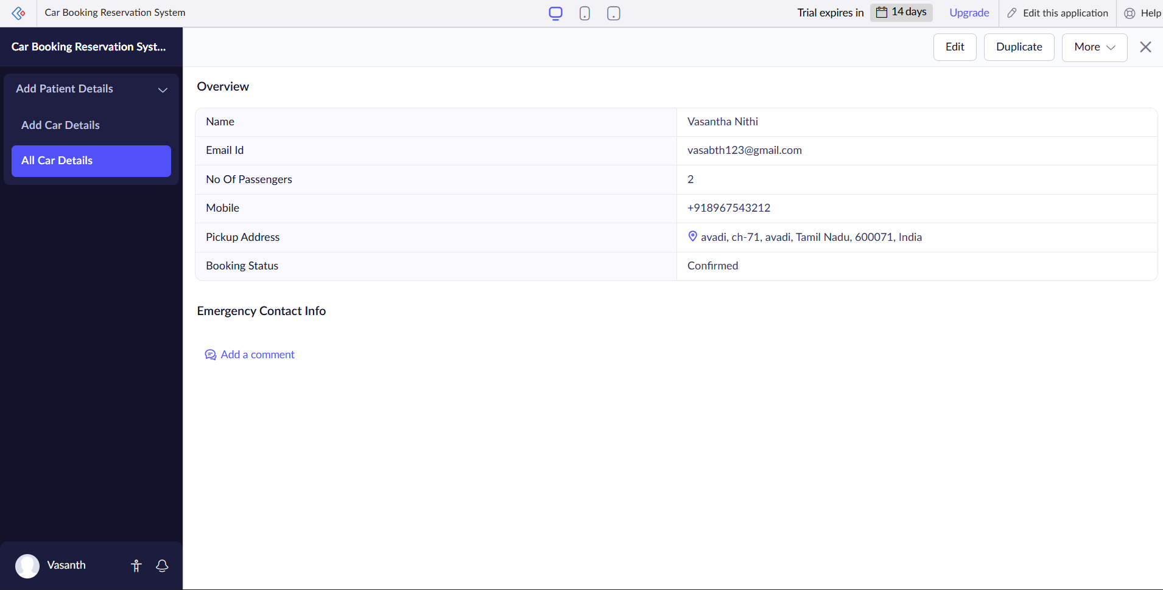

**Result:**

* The **Car Booking Reservation System** was successfully developed using **Zoho Creator**.
* Customers can enter journey details and reserve cars online.
* Bookings are stored in a **centralized cloud database**.
* Reports allow easy monitoring and filtering of reservations.
* The app is **accessible via browser or mobile app** without installation, thereby demonstrating the **SaaS model**.